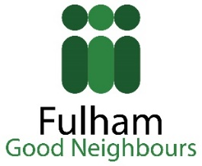
Parsons Green Fair Volunteer (Marshall/Event Steward) Role Description
Summary of the role and the activities involved:-

Role
You will assist people visiting the fair and help make sure that it is a safe and welcoming event for all attendees. The role will involve:
- Assisting with setting up the Fair (morning shift) and dismantling the Fair (late afternoon shift)
- Directing people
- Dealing with lost children
- Dealing with lost property
- Collecting rubbish
- Selling Raffle Tickets
- Asking people to leave The Green if due to an emergency the Fair needs to be closed down unexpectedly.

Personal qualities most suited to this role
- A friendly and cheerful manner
- Patience
- Good listening skills
- Good timekeeping skills
- Good problem-solving skills
- Health & Safety Awareness

How many hours you need to give, when and where:-
You can choose between the following shifts on Saturday, 3rd July 2021:
7:00-11:00
10:45-14:45
14:30-18:30

What training will be necessary and available:-
An induction will take place on Tuesday, 29th June 2021 at 6.00 PM, at St Dionis Church, 18A Parsons Green, London, SW6 4UH. This will last less than an hour and you are expected to take part in it. There will be another session, for those who are at work at that time or don’t live locally, on Saturday, 3rd July 2021 at 10 AM.

Who will supervise you:-
Your supervisor on Fair day will be Jac Davies Tel. 020 7385 8850
Email: info@parsonsgreenfair.org but if you have any questions beforehand, please email chrismikata@fulhamgoodneighbours.org

What expenses are payable and what benefits are available:-
Your travel expenses will be provided and we will reimburse your lunch costs up to £5. Two of your children or grandchildren under the age of 12 will also benefit from free rides on all the children attractions.

